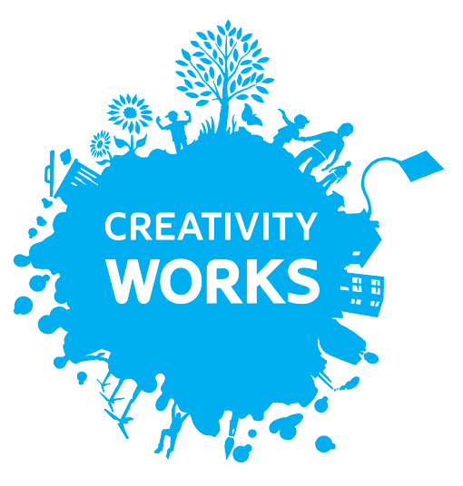

Creativity Works Job Description

Office and Project Assistant – Kickstart Placement

Part time: 25 hours per week
Responsible to: The Director of Creativity Works
Works with: Creative Wellbeing Programme Manager, Marketing & Communications Coordinator and Artist Development Manager
Based at: Leigh House, 1 Wells Road, Radstock, BA3 3RN

About Creativity Works:

Creativity Works is an award-winning charity and socially engaged arts organisation based in Radstock, Bath and North East Somerset (B&NES), delivering creative projects that make a real difference to people’s lives.

The focus of our work is on Mental Health and Wellbeing with specific communities, including adults living with mental health challenges, vulnerable young people, elders and those living with dementia, mums with post-natal depression and carers.

We work with people of all ages and backgrounds who need support and inspiration. Our central aim is to use the power of the creative process to draw communities together and enable more people to access the arts.

Working with professional artists & wellbeing specialists, we run creative projects and programmes & facilitate community events that inspire people to explore, develop & grow.

Creativity Works has been working in B&NES for 40 years, developing a core of artists in a variety of disciplines who support our creative work in local communities.

www.creativityworks.org.uk

We actively encourage people from communities that are under-represented in the UK arts and culture sector to apply to join us, and bring their talent, experience and skills to Creativity Works.

What can you expect from us?:

The Kickstart post – Office and Project Assistant will be an essential member of the Creativity Works team. Throughout your 6 months you will be able to access free training including: Safeguarding, Mental Health and Equality, Inclusion and Diversity. We will introduce you to both local and national arts and community networks and support you in future job searches, applications and interviews. Creativity Works has a flexible working policy, a generous pension scheme and a commitment to supporting employees’ professional development.

Job Purpose:
To work with the Staff Team to assist in the administration, documentation and promotion of Creativity Works projects and events, and support office administration and archiving.

Key Duties:
- Support Projects administration such as booking venues, ordering materials and equipment, liaising with participants and artists, promoting and supporting both live and digital events and activities
- Filing and record keeping for projects and supporting data collection and input into evaluation reports
- General office administration including answering the telephone, taking messages, ordering stationary, printer consumables and archiving

Key Tasks:
- Office admin including answering telephone calls, taking messages, ordering stationary, filing and maintaining stationary cupboard
- Working alongside staff team to support the archiving of all our past projects both physical and digital
- Support the day-to-day administration of live projects including arranging and booking venues, ordering equipment and materials, filing and general admin duties assigned to you by project leads
- Support project leads to file current project data on our various IT systems/platforms
- To support the collation, input and dissemination of monitoring and evaluation data from projects and events
- Assist in the production and distribution of project marketing materials, including invitations, artwork, posters, leaflets etc
- To assist Staff Team with general internal and external communications
- Attend and note take at staff meetings
- Attend and support Project Meetings with project leads
- Help identify potential sources of external funding such as funding from Trusts and Foundations
- Undertake market research and evaluation feedback through helping design surveys and focus groups questions

General
- To act in the best interests of Creativity Works
- To work within Creativity Works’ policy framework
- To undertake any other duties and responsibilities commensurate with the post

Essential |  | Desirable
Qualifications

Equivalent to 3 GSCE grade A*-C’s |  | Equivalent to 2 AS/A-Levels grade A*-C’s
Interests
Arts, culture, heritage  And/or:  Working with people and communities | Working in a charity/voluntary sector organisation
Experience

Some experience of general project administration and/or office administration |  | Experience of working as part of a team to co-ordinate events
Some experience of production and dissemination of marketing materials |  | Knowledge of how to post on social media/online platforms
Some experience of customer facing roles
Knowledge and skills

Basic IT skills |  | Understanding of Office 365, Canva
A commitment to and understanding of equality, diversity and inclusion |  | Previous work/volunteering with a wide range of people and communities
Good communication skills both written and verbal |  | Willingness to speak on behalf of an organisation
 |  | Understands Health and Safety at work
Personal Qualities

Ability to work well as part of a team
Good time keeping and punctuality
Willingness to learn and develop skills through training
Self-motivated and ability to manage own time effectively with some supervision |  | Ability to work away from the office via remote working and remain on task
 |  | The ability to respond positively/creatively to challenges and changes
A commitment to the aims and ethos of Creativity Works
Ability to work flexibly including some evenings and weekends

Conditions of Service (Summary)

Grade / Salary: National Minimum wage or the National Living wage depending on the age of the participant

Hours: 25 hours per week for a fixed term of 6 months

Special Conditions: The hours worked may require evenings and weekends

Pension: Eligible to join Creativity Works’ stakeholder pension scheme to which the employer makes a 5% of salary level contribution

Overtime: Overtime payments are not made. Time off in lieu is provided

Expenses: Travel during the course of Creativity Works business will be reimbursed and mileage paid at the current Creativity Works rate

Probationary period: 4 weeks (within the probationary period, the notice period either way is 1 week)

Notice period: 4 weeks post successful probation period

