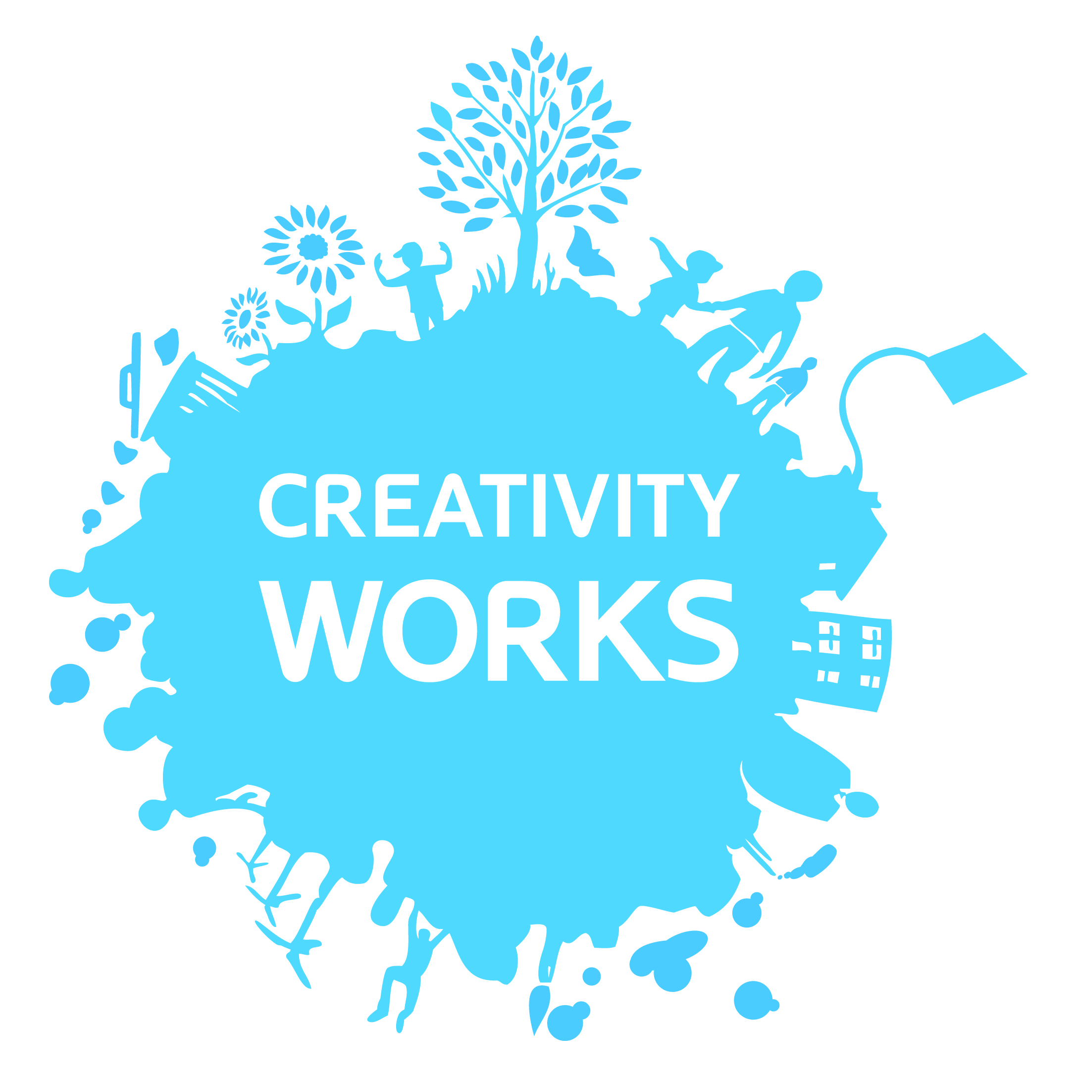

Creativity Works Job Description

Business Development Manager

Responsible to: The Director and the Board of Trustees
Responsible for: Any freelance staff and volunteers associated with the Business Development programme
Job Purpose:
- Fundraising
- New Business Development
- Partnership Development and Communications
- Development and Progression support for CW projects and programmes

Key Objectives:

To identify and grow new and existing revenue streams in order to improve financial performance

To act as an ambassador for the organisation, identifying and establishing strong partnerships for delivery

To oversee resource, evaluation and research development

Key Outputs
- Identify and secure diverse forms of financial support, especially commissions
- Identify and secure appropriate fundraising from trusts and foundations
- Consolidate, develop and implement market opportunities (and create new opportunities where appropriate) that contribute to the long term stability and vision of Creativity Works
- Help create, articulate and implement a strong vision and distinctive identity across all aspects of the organization through research, evaluation and impact methodologies
- Contribute to the organisation’s business planning process
- Contribute to the development of key partnerships with a range of organisations and key stakeholders to ensure ability to bid effectively to deliver public service commissions and attract donations and sponsorship
- Act as a spokesperson and ambassador for the organisation, and champion Creativity Works regionally and nationally
- Ensure that the organisation’s interests are protected and advanced
- Ensure that the organisation is compliant with the risk management of business initiatives.
- Operate in accordance with the organisation’s employment, Health & Safety, equal opportunities and other legal requirements, organisational practices, policies and procedures

Conditions of Service (Summary)
Grade / Salary: £29,371 pro rata
Hours: 22.5 hours per week
(with the potential to increase to 30hrs per week dependent on successful fundraising)
Pension: Eligible to join Creativity Works’ stakeholder pension scheme to which the Board of Trustees make a 5% of salary level contribution.

Project Manager: Person Specification
Essential | Desirable
Qualifications
Educated to degree/HND level or equivalent
Experience
At least three years’ experience of working within a managerial position in business development | Experience of health and social care commissioning
Proven experience of successful fundraising
Proven experience of managing freelance staff and volunteers | Managing Arts/Development Workers
Delivering key funders’ aims and objectives | Experience of working in participatory arts
At least three years’ experience of managing and developing arts [or similar] organisations/projects | Experience of working within both urban and rural areas
Managing and monitoring budgets
Identifying project marketing and PR requirements | Devising marketing and PR outputs
Knowledge of and/or Skills in:
A thorough understanding and experience of the commissioning process | A thorough understanding of Creativity Works’ model of working, policies and procedures.
Wellbeing and health, community development and social inclusion issues | A wide variety of art forms both traditional and new
Partnership working | Community development issues across Bath & North East Somerset
Motivating and enthusing others in delivering a coherent and inspiring project | Socially Engaged Arts best practice
Commitment to and understanding of equality and diversity issues and ability to deliver and monitor Creativity Works’ Equality and Diversity Policy
Excellent Computer skills
Communication both written and verbal, including the ability to speak on behalf of an organisation | Publicity/marketing and presentation skills
Ability to develop and work within good health and safety policy and practice
Personal Qualities
Strong self-motivation and ability to manage own time effectively with minimum supervision
The ability to respond positively/creatively to challenges and changes
A commitment to the aims and ethos of Creativity Works

